EENG 385 - Electronic Devices and Circuits

BJT Curve Tracer: Schmitt Trigger Relaxation Oscillator

Lab Document

# Objective

The objective of this lab is to introduce the use of positive feedback in the construction of an oscillator.

# Analysis Schmitt Trigger Relaxation Oscillator

During today’s lab you will build the circuit shown in Figure 1, a Schmitt Trigger Relaxation Oscillator. At the outset, I need to be clear, the engineering objectives of this lab could be accomplished with a 555 Timer. However, the education objective of this lab is to explore the use of positive feedback in an op amp to generator oscillatory behavior.

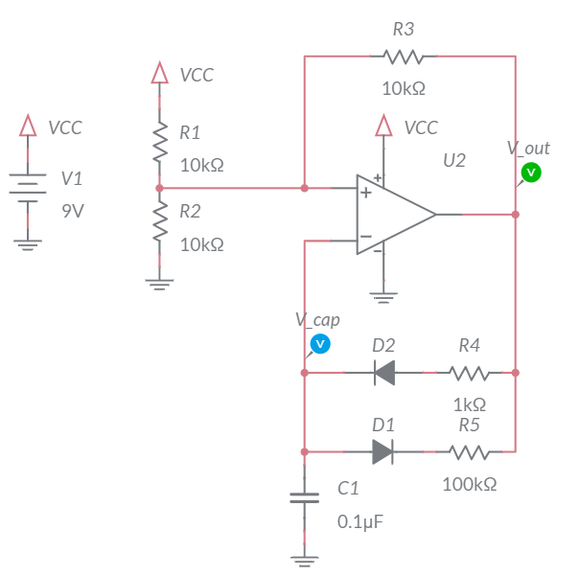

Figure : The Schmitt Trigger Relaxation Oscillator. The output is taken from the op amp output.

In order to analyze the circuit in Figure 1, you need to understand the behavior of a Schmitt Trigger ‒ a circuit with one input, *Vin*, and one output, *Vout*. The Schmitt Trigger compares *Vin* against two voltage levels, *Vhigh* and *Vlow* and assigns the output as follows:

* If (*Vin* > *Vhigh*), then *Vout* = VCC
* If (*Vin* < *Vlow*), then *Vout* = 0V
* If (Vlow < *Vin* < *Vhig*h), then *Vout* remains unchanged

The behavior is captured in Figure 2, a graph of *Vin* vs. *Vout*.

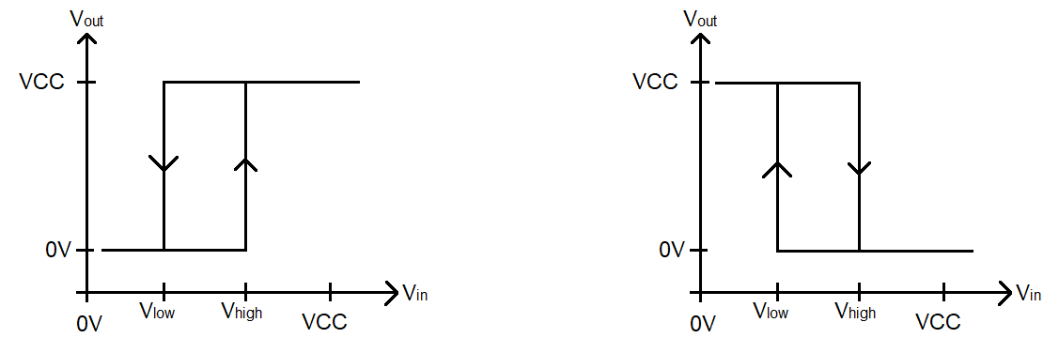

Figure : Input, output relationship for a Schmitt Trigger is characteristic of a system with hysteresis. Left a normal Schmitt Trigger and right, an inverting Schmitt trigger.

Let’s focus on the curve to the left in Figure 2. To understand this figure, use your finger to point to the region of the horizontal axis (the *Vin* axis) which corresponds to *Vin > Vhigh*. Look above this region and you will see a horizontal line corresponding to *Vout =* VCC. Likewise for *Vin < Vlow* you should see that *Vou*t = 0V. The tricky part of the graph is when *Vin* is between *Vlow* and *Vhigh*. In this region, *Vout* holds on to the value it had before *Vin* entered the region between *Vlow* and *Vhigh*.

For example, let’s say *Vin* = VCC, so we know for sure that *Vout* = VCC. Now, let *Vin* decrease slowly, all the while *Vout* will stay at VCC. At some point *Vin* will become equal to and then just a smidge lower than *Vhigh*. At this point, *Vhigh* will remain unchanged at stay at VCC. As *Vin* decreases towards *Vlow, Vout* will remain at VCC. Only when *Vin* decreases, just a smidge, below *Vlow* will *Vout* switch its value to 0V. This transition is represented in Figure 2 by the downward arrow on the line connecting VCC to 0V at *Vin = Vlow*.

Similarly, as *Vin* increases from 0V towards *Vhigh*, the output, *Vout,* will stay at 0V. Only when *Vin* increases above *Vhigh* will the output change to VCC. This transition is represented in Figure 2 by the upward arrow on the line connecting 0V to VCC at *Vin = Vhigh*.

Systems with hysteresis are well suited to reject noise from signals. Consider the example shown in Figure 3 where the top analog signal (red line) is converted into digital signal. The middle signal shows how the analog is converted when a single threshold (the grey line between *Vhigh* and Vlow) is used to classify the analog signal as 1 when it is above the grey line and 0 when the analog signal is below the grey line. Any noise on the analog signal will cause this scheme to make several digital transitions.

The bottom graph in Figure 3 shows how the analog signal is converted when two thresholds, *Vhigh* and *Vlow*, and hysteresis are used to classify the analog signal. In this scheme, the signal is classified as 0 when the analog signal is below *Vlow* and classified as 1 when the analog signal is above *Vhigh*. When the analog signal is between the two thresholds, it retains its previous value. The resulting digital signal is much more immune to noise on the analog signal.

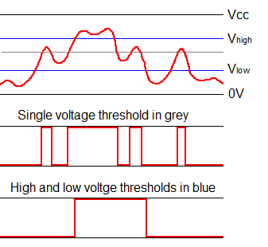

Figure : The top signal (in red) is converted into a digital signal using the single grey threshold (middle) and the 2 blue thresholds (lower).

Figure 4 shows a Schmitt Trigger built using an op amp and resistors. Can you identify the parts of this circuit used in the circuit shown in Figure 1? Note, the resistors are the same in both figures.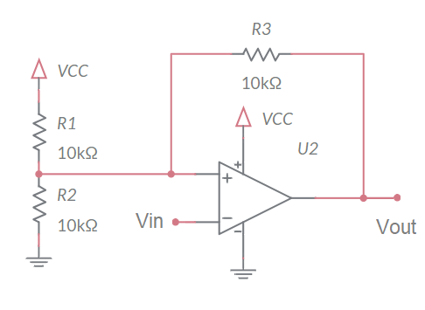

Figure : A Schmitt Trigger built using an op amp. Don’t forget to add a 9V power supply!

Answer the following questions to understand the behavior of the circuit in Figure 4.

1. Assume *Vout* = 9V. What is the voltage at the non-inverting input of the op amp? Call this voltage *Vhigh*. *(Hint: Combine the parallel resistors then use Ohm’s law.)*

**R4 in parallel with R8 is equivalent to 33 kΩ*15 kΩ / (33 kΩ + 15 kΩ) = 10.3 kΩ**

**So *Vhigh* = 9V*33 kΩ / (33 kΩ + 10.3 kΩ) = 6.86V**

1. Assume *Vout* = 0V. What is the voltage at the non-inverting input of the op amp? Call this voltage *Vlow*. **R4 in parallel with R6 is equivalent to 33 kΩ*15 kΩ / (33 kΩ+15 kΩ) = 10.3 kΩ***(Hint: Combine the parallel resistors then use Ohm’s law.)*
2. **So *Vlow* = 9V*10.3 kΩ / (33 kΩ + 10.3 kΩ) = 2.14V.**Imagine *Vin* is at 0V. What is *Vout*? *(Hint: The voltage on the non-inverting input of the op amp is greater than Vlow.)*

**If *Vin* = V- = 0V and V+ >= *Vlow* = 2.14V then V- < V+ so *Vout* = 9V.**

1. Imagine increasing *Vin* from 0V to just below *Vhigh*. What is *Vout*? *(Hint: Use Vout from the Q3, since you are starting at 0V, to determine the value of non-inverting op amp input from Q1.)*

**If *Vin* = V- and V+ = *Vhigh* = 6.86V, then V- < V+ so *Vout* = 9V.**

1. Imagine *Vin* continues to increase and goes just above *Vhigh*. What is *Vout*?

**If *Vin* = V- > V+ = *Vhigh*, then *Vout* = 0V.**

1. Imagine *Vin* is at 9V. What is *Vout*? *(Hint: The voltage on the non-inverting input of the op amp is at least Vhigh.)*

**If *Vin* = V- = 9V and V+ <= *Vhigh* = 6.86V, then V- > V+ so *Vout* = 0V.**

1. Imagine decreasing *Vin* from 9V to just above *Vlow*. What is *Vout*? *(Hint: Use Vout from the Q6, since you are starting at 9V, to determine the value of non-inverting op amp input from Q2.)*

**If Vin = V- and V+ = *Vlow* = 2.14V, then V- > V+ so *Vout* = 0V.**

1. Imagine *Vin* continues to decrease and goes just below *Vlow*. What is *Vout*?

**If *Vin* = V- < V+ = *Vlow,* then *Vou*t = 9V.**

1. Use this information to draw *Vin* vs. *Vout* hysteresis diagram similar to Figure 2. Label the *Vin*- axis with the voltage values for *Vlow* and *Vout* found in Q1 and Q2.

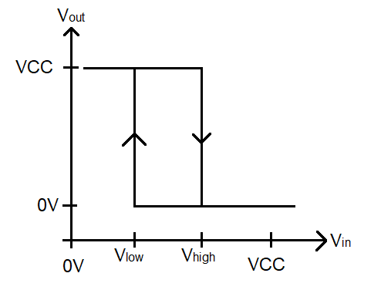Now with your solid understanding of the Schmitt Trigger circuit in Figure 4, it is time to apply your understanding to the operation of the larger circuit in Figure 1. Do this by working through the following questions.



1. Assume *Vout* = 9V. In this case, there is a path for electrical flow from *Vout* through R4, through the (forward biased) diode D2, to the capacitor C1 to ground. Diode D1 is reverse biased so it eliminates the 100kΩ resistor from the circuit. What is the time constant for this charging? *Hint: You can replace the forward biased diode D2 with a wire.***Time constant = RC = 3.3 kΩ * 0.1 µF = 0.33 ms**
2. Use this time constant to write an equation describing the voltage on capacitor C1.
3. Compute the time required for capacitor C1 to charge from *Vlow* to *Vhigh*
   * Set the equation derived in Q11 equal to *Vhigh* and solve for *t*. Represent your answer in microseconds and round to the nearest integer.
   * Set the equation you derived in Q11 equal to *Vlow* and solve for *t*. Represent your answer in microseconds and round to the nearest integer.
   * To derive the time to charge C1 from *Vlow* to *Vhigh*, subtract the time to get to *Vhigh* from the time to get to *Vlow*.

**470 – 90 = 380**

1. Assume *Vout* = 0V. In this case, there is a path for electrical flow from the charged plate of the capacitor C1 through the (forward biased) diode D1, through resistor R5 to *Vout* = 0V. Diode D2 is reverse biased so eliminates the 1kΩ resistor from the circuit. What is the time constant for this discharging? *(Hint: You can replace the forward biased diode D1 with a wire.)*

**Time constant = RC = 33 kΩ * 0.1 µF = 3.3 ms**

1. Use this time constant to write an equation describing the voltage on capacitor C1.
2. Compute the time required for the capacitor C1 to discharge from *Vhigh* to *Vlow* as follows.
   * Set the *Vt(t)* equation equal to *Vhigh* and solve for *t*. This equation gives the time to discharge from 9V to *Vhigh*. Represent your answer in milliseconds and round to three significant figures.
   * Set the *Vt(t)* equation equal to *Vlow* and solve for *t*. This equation gives the time to discharge from 9V to *Vlow*. Represent your answer in milliseconds and round to three significant figures.
   * To derive the time to discharge C1 from *Vhigh* to *Vlow*, subtract the time to get to *Vhigh* from the time to get to *Vlow*.

**4.74 ms – 0.89 ms = 3.85 ms**

Note, the capacitor C1 is connected to the inverting input of the op amp in Figure 1. Thus, the charge on this capacitor plays the role of *Vin* in Figure 4 and in the graph produced in Q9. Use your answers to these and other questions to answer the following two questions. Make sure to fill in the blanks and choose an option when a pair of **items** are separated by a “**/**”.

1. When *Vout* = 9V, then the capacitor C1 is **charging charging**/**discharging** from *Vlow* to *Vhigh*. The capacitor takes ____µs to go from *Vlow* to *Vhigh*. When the **charging** charging/discharging capacitor’s voltage exceeds ***Vlow* /*Vhigh* *Vhigh*** then *Vout* = 0V. When *Vout* = 0V, the capacitor will start to **charge/discharge** **discharge**.
2. When *Vout* = 0V, then the capacitor C1 is **charging**/**discharging** **discharging** from *Vhigh* to *Vlow*. Now the capacitor takes ____ ms to go from *Vhigh* to *Vlow*. When the charging/discharging **discharging** capacitor’s voltage drops below ***Vlow**Vlow*/*Vhigh*,** then *Vout* = 9V. When *Vout* = 9V, the capacitor will start to **charge charge/ discharge**.

Thus, *Vout* oscillates between 9V and 0V with the characteristics of the waveform determined by the time required to charge and discharge the capacitor C1. Use the information from this section to fill in the **Analysis** columns of Table 3 and Table 4.

# Simulation Schmitt Trigger Relaxation Oscillator

Build the circuit in Figure 1 using MultiSim Live. Make sure to attach probes to the output of the op amp and the inverting input of the op amp. The parts list is similar to last weeks; just in case, the bill of materials is given in Table 1.

Table : The parts list for the Schmitt Trigger Relaxation Oscillator.

|  |  |  |
| --- | --- | --- |
| **Component** | **Tool** | **Name** |
| DC Voltage Supply | Sources | DC Voltage |
| Ground | Schematic connectors | Ground |
| VCC | Schematic connectors | Connector |
| Resistor | Passive | Resistor |
| Capacitor | Passive | Capacitor |
| Diode | Diodes | Diode |
| Op amp | Analog | 5 Terminal Op amp |

Once you have completed the schematic, use the export option in the main menu to output a PNG file of the schematic. Then, make some important changes in order for the simulation to run correctly.

* Set the initial voltage on the 0.1 µF capacitor to 0V. Do this by opening the 0.1 µF capacitor’s properties, checking the box next to IC and entering the value “0” in the text box. 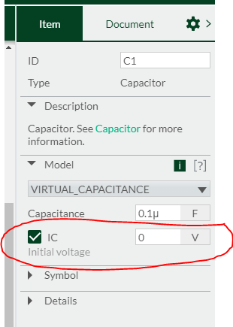
* Set the simulation time step to 1 µs. Do this by opening the document properties menu, expanding the **Maximum** **time step** option, checking the “Manual time step” checkbox and filling “1e-7” in the “Time step” text box.
* In this same menu, change the simulation End time to 25ms by filling “25m” in the “End time” text box.
* In this same menu, change the Initial Conditions to “User defined” by selecting this option from the pull-down menu.

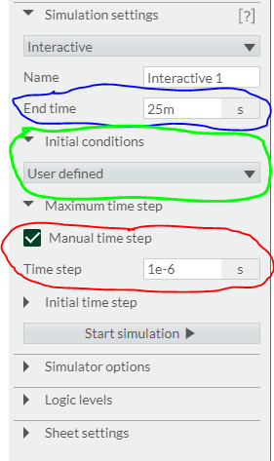

Include one wavelength of the output and capacitor voltage in your answers. You can use the export option in the main menu to output a PNG file.

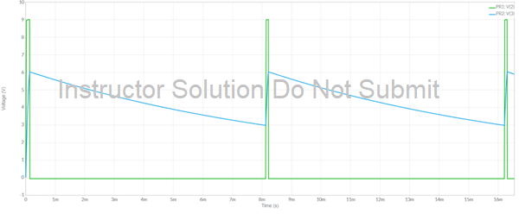

Figure : Simulation output of the circuit shown in Figure 1.

Use the *Vout* waveform to fill in the **Simulation** column in Table 3. You may want to use the cursors function available in the Item tab. If you do not see this tab, double click on a blank area of the timing diagram to make it appear.

Use the *Vcap*waveform to fill in the **Simulation** column in Table 4. Fill in the *Vhigh* row with the highest voltage appearing on the *Vcap*waveform. Fill in the *Vlow* row with the lowest voltage appearing on the *Vcap*waveform.

# Empirical Schmitt Trigger Relaxation Oscillator

This week, you will be soldering in the components associated with the SCHMITT TRIGGER RELAXATION OSCILLIATOR subsystems. This subsystem is named in Figure 6. You should solder in all the components associated with this subsystem and the resistor R10 for the RESET CIRCUIT. This lab document contains cursory coverage of the assembly process. You can find much more detail in the Assembly Guide posted on Canvas.

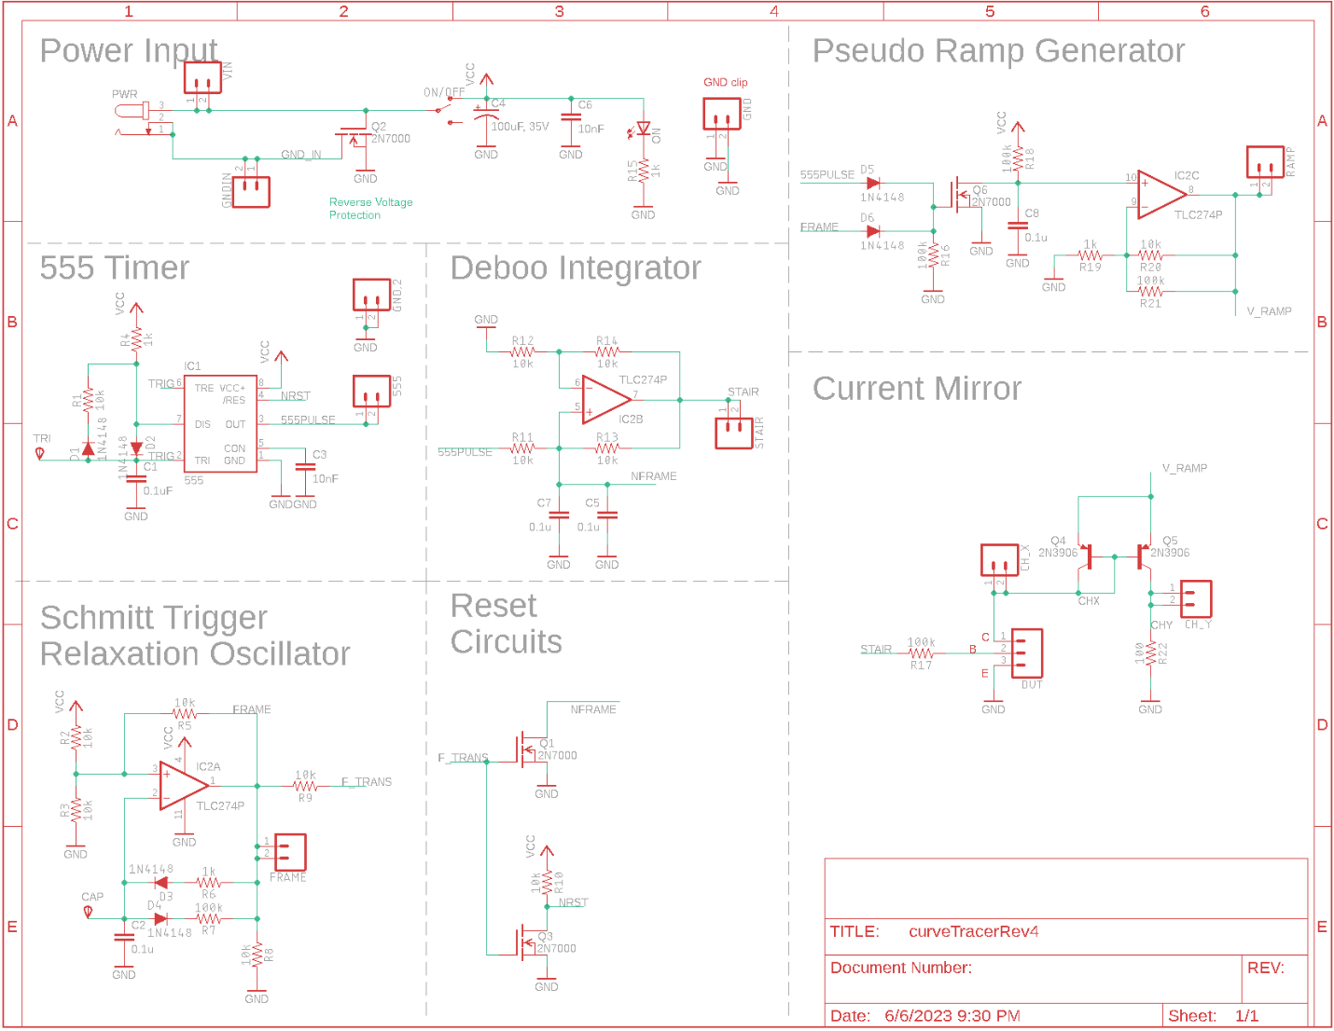

Figure : The schematic for the overall BJT curve tracer.

## Part Identification

To make sure you can positively identify all the elements in the schematic, complete Table 2 by filling in the **Match** column with the letter corresponding to the **Schematic Symbol** for a **Physical Part**.

Table : Match the schematic symbol with the corresponding part.

|  |  |  |  |
| --- | --- | --- | --- |
| **Schematic Symbol** |  | **Match** | **Physical Part** |
| A |  | D | Mono-Kap H5 |
| B |  | C | CF 4-7k |
| C |  | E |  |
| D |  | B | DO-35 |
| E |  | A |  |

## Testing

Once you have completed assembly of your SCHMITT TRIGGER RELAXATION OSCILLIATOR subsystem, perform the following test.

1. Power up an oscilloscope. Attach a probe to Channel 1 and configure it as follows.

|  |  |
| --- | --- |
| Ch 1 probe | FRAME test point (Vout) |
| Ch 1 ground clip | GND test point |
| Horizontal (scale) | 1 ms |
| Ch 1 (scale) | 1 V or 2 V (whatever fits better) |
| Ch 2 probe | Inverting input of op amp (Vcap) |
| Ch 2 (scale) | Same as Channel 1 |
| Trigger mode | Auto |
| Trigger source | Ch1 |
| Trigger slope | ↑ |
| Trigger level | 4.5V |

1. Set the GND reference of Ch 1 and Ch 2 to the lowest visible reticule – the waveforms will overlap the same as they did in the MultiSim simulation. Set the horizontal position of the trigger to the left most visible reticule. Note, the op amp output is sent to the FRAME test point. The capacitor charge is available by attaching an oscilloscope probe to the CAP test point shown in Figure 8.

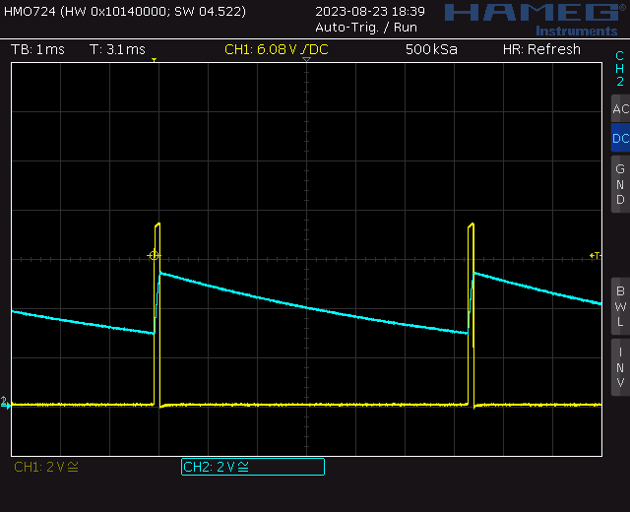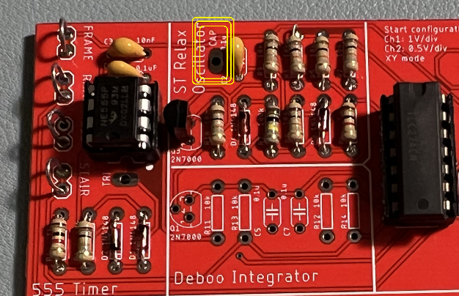

Figure : (Left) You can probe the capacitor voltage at the yellow circled test point. (Right) An oscilloscope trace showing the two output you need to capture. Note that this image was captured on a Rhode&Schwarz HMO724.

1. Take a screen shot of the of the *Vout* and *Vcap* waveforms and include them in your lab report. Screen shot the oscilloscope traces on USB. Cell phone pictures will lose points.  
   [Save] → Save → Format → 24-bit Bit... (*.bmp) [Save] → Save → Press to Save

You may want to apply the Acquire function to average 32 waveforms together to smooth the waveforms.

Use the data collected from the oscilloscope to fill out the **Assemble** columns in Table 3, and Table 4.

# Comparison

Complete the **Analysis, Simulation** and **Empirical** columns of the following tables using the information you found throughout this lab. Represent your answer to 3 significant figures using the units given in parenthesis in the **Quantity** column. You will need this table in later labs, so keep it handy.

Table : Summary of Vout behavior in the Schmitt Trigger Relaxation Oscillator.

|  |  |  |  |
| --- | --- | --- | --- |
| Quantity | Analysis | Simulation | Empirical |
| Time high (us) | 89 us | 0.46 ms | 0.56 ms |
| Time low (us) | 3.85 ms | 4.6 ms | 4.35 ms |
| Period (us) | 4.23 ms | 8091 us | 4.9 ms |
| Frequency (Hz) | 236 Hz | 198 Hz | 203 Hz |
| Duty Cycle | 9.0% | 9.1% | 11.4% |

Table : Summary of the 0.1µF capacitor voltage in the Schmitt Trigger Relaxation Oscillator.

|  |  |  |  |
| --- | --- | --- | --- |
| Quantity | Analysis | Simulation | Empirical |
| *Vhigh* (volts) | 6.7 V | 6.89 V | 6.3 V |
| *Vlow*(volts) | 2.14 V | 2.11 V | 2.4 V |

# Turn In:

1. Make a record of your response to numbered items below and turn in a single lab report for your team on Canvas using the instructions posted there.
2. Include the names of both team members at the top of your solutions.
3. Use complete English sentences to introduce what each of the items listed below is and how it was derived.

Hint, use Ctrl+click to follow links. This also works for all the Figures and Tables in these labs.

**Analysis Schmitt Trigger Relaxation Oscillator**

Steps 1 – 17.

**Simulation Schmitt Trigger Relaxation Oscillator**

Schematic (use Export -> Schematic Image).

Timing diagram (use Export -> Grapher Image).

**Empirical Schmitt Trigger Relaxation Oscillator**

CompleteTable 2**.**

Screen capture of Schmitt Trigger Relaxation Oscillator output

**Comparison**

Table 3 and Table 4. Compare timer output in different models.